**DECLARATION**

I hereby declare that the Project report entitled **"Web Scraping using Python and Flask"** submitted to the Department of Computer Science & Engineering, SIET Nilokheri in partial fulfilment of the requirements for the award of the degree of Bachelor of Technology (ComputerEngineering) is a record of original work done by me, under the guidance and supervision of Mrs. Rama and it has not formed the basis for the award of any Degree/Diploma/Associateship/ Fellowship or other similar title to any candidate of any University.

Dated Signature of the Candidate

**Approval or Certification**

MSME Technology Center Bhiwadi Domain in Python approved Certificated by this Bhiwadi center.

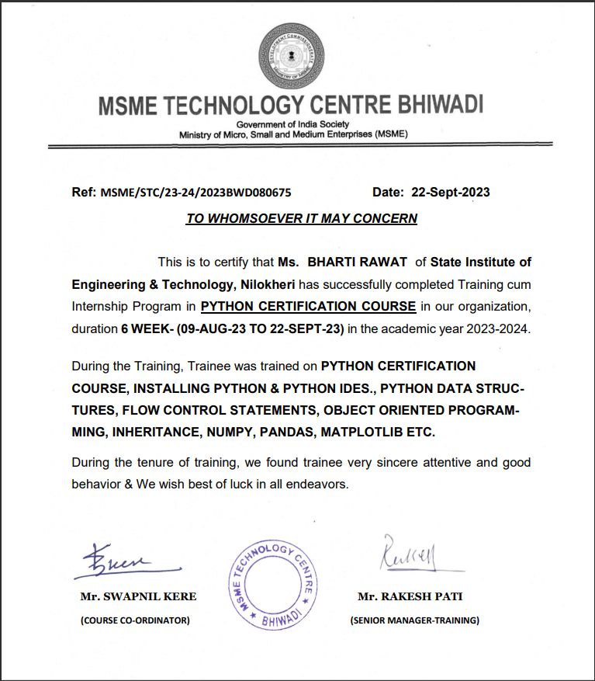

Fig. 1.1 Certificate

**Certificate**

It is certified that the work contained in the project report titled “**Web Scraping using Python and Flask**,” by “Bharti Rawat”has been carried out under my/our supervision and that this work has not been submitted elsewhere for a degree.

Signature of Supervisor

Name:

Department:

Signature of Head of Department

State Institute of Engg. & Tech. Nilokheri

**Acknowledgement**

The acknowledgement page depicts the gratitude, respect and thankfulness of the student towards the people who helped him in pursuing the project successfully and ensured successful completion and implementation of the project. In this page, the author expresses his gratitude and concern by using praising and thanks giving words.

**Abstract**

"Web Scraping with Python and Flask: This project involves creating a web application using Flask to perform web scraping. Users input a URL, triggering a Python script to extract and display relevant data from the specified webpage. The application employs Beautiful Soup for parsing HTML and requests for fetching web content. User-friendly interfaces are implemented using Flask forms, allowing users to customize scraping parameters. The scraped data is presented dynamically on the web page.

**List of Figures**

Fig. ii(1) Certificate ii

Fig. 1.2 Web Scraping 1

Fig. 5.1 Output 12

**TABLE OF CONTENTS**

**Page No.**

Declaration ii

Approval or Certification iii

Certificate iv

Acknowledgement v

Abstract vi

List of Figures vii

Table of Content viii

**Chapter**

1 Introduction 1

2 Literature Survey 4

3 Methodology Used 6

4 Virtual environment ,flask

5 Source code of project 8

6 Results / Snapshots 12

7 Conclusion and Recommendation 13

References 14